**Name :** kalyani vaman mane

**Enrollment :** 2205690259

**Roll no :** 14

**DIV :** co-a

**Deparment :** computer

**6 EARTHING**

**PROTECTIVE DIVECE AND SWICHTGE**

**function of fuse**:

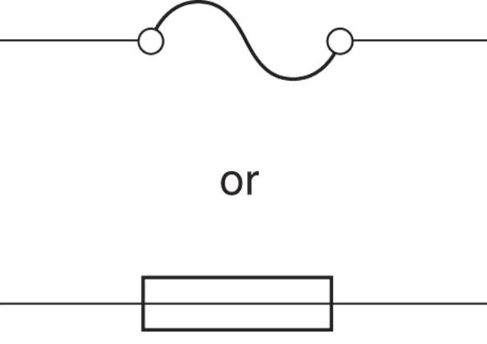

•To brtak the cireuit Fault condition.

•To provide overcurrtnt protect to the ciruit

•To provide short ciruit protcetion to the ciruit

* To provide safety to the ueser

**Function of switch**

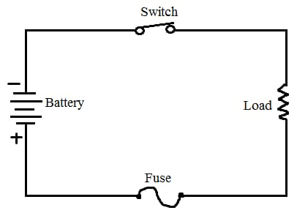

•To maKe the electric circust manudlly

•To braK the elettric cireuit manually

**WORKING OF FUSE**

•The working principal of the fuse is based upon "heating effect of the electric current".

* It is Fabricated in a form of strip or thread of metallic wire
* The connection of the Fuse in an electrical circuit is dlways in series with device that is to be protected
* Due to heavy Flow of current in the electrical circuit the Fuse gets melted soften and it opens the circuit
* The extreme flow of current may of direct to the collapswire and disconnection of circuit that is protected

**TYPE OF FUSE**

* Rewriteable fuse Ceramic
* Tinned Copper
* HRC Fuse.
* Brass End Cap
* Fusing Element
* Link Type Fuse
* Strikey type Fuse
* Switch Type Fuse

**Types of Earthing Plate Earthing**

• Excavation on earth For a normal Pit of size

2.7M X 0.6M X 3.0M OR 4.5M.

• For plate type earthing normal practice is to use copper or Gil plate.

Plate id buried into the ground at depth. more than 3 meters from gro 10-11/13

These types of earth pit are general. with alternate layer of charcoal & salt up to 4 feet from bottom to pit.

• The electrical installation which to be earthed i connected to top of earth plate by means of copper or aluminium earth continuity conductor of sufficient cross-sectional.

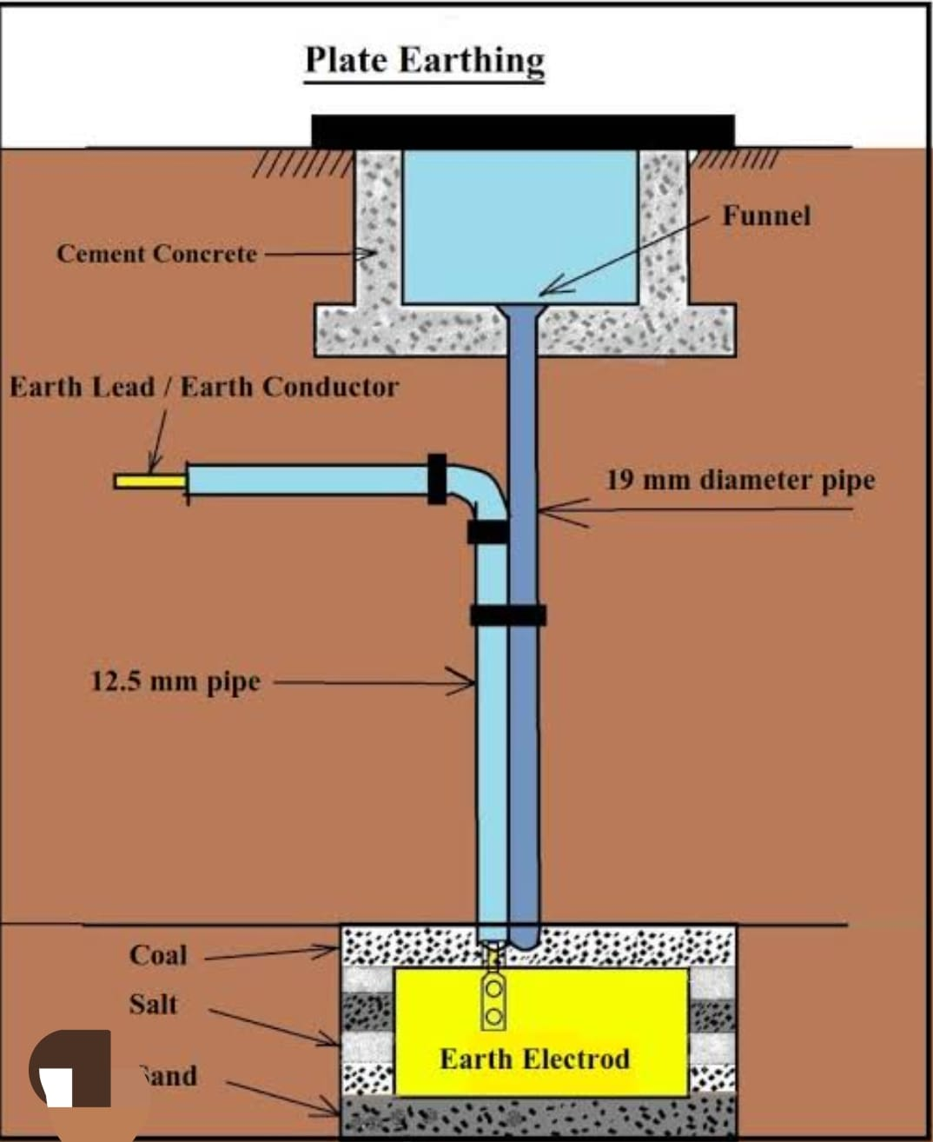

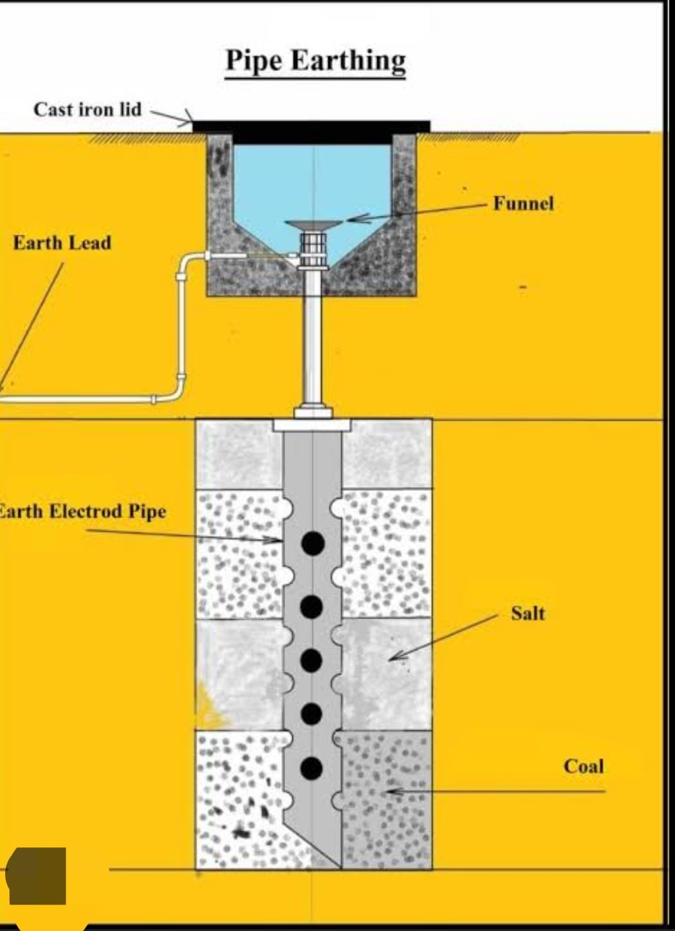

**PIPE EARTHING**!..

* Excavation on earth for a normal pit of Size 2.7M x 0.6M X 3.0M OR 4.5M. For pipe type earthing normal practice is use
* G pipe [C-class] OF 75mm diameter of length. Having 6 Numbers of holes for the Connection of earth wires.
* Normal practice is to use G1 earthing pipe of length as per requirement.
* Cover Top of cut pipe with a T joint to avoid jamming of pipe with dust & mud.
* These types of earth pit are generally filled with alternate layer of charcoal 2 salt up to 4 Feet From bottom of pit.
* The electrical installation which to be earthed is connected to top of earth pipe by means of copper or di uminium earth continuity conductor o Sufficient Crose - section.
* Normal practice ie to use Gel earthing wire of 10/8/6 standard wire ouage (swo) as per requirement

The operating mechanism consisting of Trip bay, spring contacts ere is used to open or close the MCCB

**Circuit breaker**

MCCB: moulded case circuit broker

working

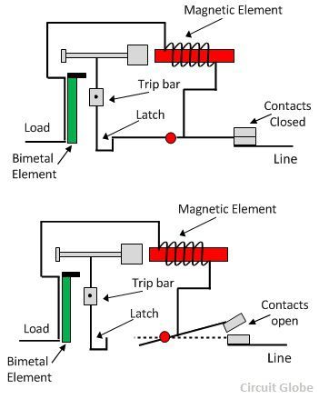

* The trip unit is the brain of circuit breakey. It senses the overload or short circuit condition and trip the mechanism is operated to trip MCCB.
* When overload occurs, the thermal relay mechanism permits overload For Short duration then bimetal strip actuates the tripping mechanism to open

the MCCB contacts

* When short circuits occurs, large magnetic dorce produced by short-circuit current operates the lever to trip the MCCB immediately and open the contact.

. **Applications of MCCB-**

* Distribution Feeders.
* Distribution transformers.
* Diesal generating sets.
* LT capacitors
* Recrifie panels.
* UPS electronic equipment.
* Motors

-**Applications of MCB:**

* Used in lighting circuits. .
* Used in distribution Feedeys
* Used in switching
* Morors.
* Used in capacitors
* Used in power circuits control transformers.
* Used in
* →ELCB

**ELCB**

It is safety device used in electrical machine to avoid electrical shocks and protect humans When current teards- leaks it breaks the circuit and no current flows.

**working principal**

**.**

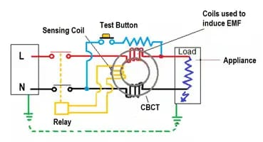

* He ELCB detects Fauit curant From live to Earth (ground) wire within the installation it protects.
* IF Sufficient voltage appears accross the ELCB 's sense coil it will switch OFF the power and main off until manually reset.
* A voltage sensing ELCB does not sense fault currents. From live to any other earthed body. From live to any other earthed body.
* It works on principal of relaying when the current in earth path exceeds a set value. Under normal conditions (IL-IN): IF is very low or nearly zero

.

* The CT Surrounding the phase and neutral senses the
* differencial current undey earth Fault and actuates
* the CB to operate loop..
* The difference current if through fault path resistance Re is the leakage to earth. If this value excceeds a preset value then the ELCB opens.

**Functions of ELCB**

* Provides protection to apparatus by detecting. the unsafe magnitudes of leakage current diverting the earth.
* Disconnect the supply to the circuit if lineto ground falut occur
* Provides protection to usexs by derecting the the unsafe magnitude of leakage current. diverting the earth

**Application of ELCB:**

* It is used for safety of the operator
* It is used to detect presence of leakage. current in a device.

r

.

**Earthing**

Earthing means connecting metallic body of the electrical equipment to earth to avoid the hazards due to leakage current

IF the leakage current Keeps circulating in the body of the equipment it might retur in electrical shock to person who touches the metallic body.

**Impartance of Earthing**

* To provide protection and safety to operator. To provide protection and safety to theequipment.
* Importance of Earthwing To provide protection and safety to operator.
* To provide protection and safety to the equipment To protect installation from sudden high vertages, switching surges with righning arrestor and surge suppressor.
* Necessity of Earthing OR Advantage of Farthing. To provide an alternative path for the leakage current to flow towards earth.
* To save human life from danger of Shock due to leakage current electrical
* To protect high rise buildings against lightening stred
* To provide safe path to dissipare lighting & short circuit current
* To provide stable platform For operation of sensitive electronic equipment's

**Types of Earthing..**

* Pipe type earthing
* Plate earthing
* Rod earthing or Driven Rod earthing.
* strip earthing or wire earthing.

**Factor affecting the Earthining**

* Soil Resistivity It should be as minimumas possible.
* Soil condition eq earthning in rocky soil is indifferent Prare earthning From wet soil.

Dissolve salts: Pure water is considered a bad conductor of electricity As amount of dissolved salt increse conductivity also. increses.

elimate condition: In dry climate the resistivity.

is high in mansoon the resistivity becomes low.

The temperature of the soil.

The depth of the electrode.

**Methods of reducing earth resistance.**

* Earth resistance can be minimized using Jollowing measurer.
* By increeing length of earth electrode
* By incresing no. of earthing rod. By treatment of the soil